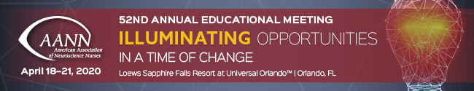

Dear Annual Meeting presenter,

Congratulations! We’re excited to have you as a speaker at the premier neuroscience nursing event. The 52nd Annual Meeting will bring together more than 1,000 attendees for an inspiring blend of preconference workshops, concurrent sessions, and networking events, centered on our meeting theme: Illuminating Opportunities in a Time of Change.

We hope our enthusiasm about your upcoming session is contagious and you’ll be inspired to share your appearance with your peers. To help promote your session, we’re proud to offer the following resources:

- News release template
- Suggested tweets
- Proposed Facebook posts

This toolkit is designed to help you make the most of your time at the Annual Meeting and share this amazing accomplishment with your contacts.

See you at #AANN20 in Orlando!
Contact: [NAME/EMAIL/PHONE]

[NAME] to Present at the 52nd AANN Annual Educational Meeting

CHICAGO—The American Association of Neuroscience Nurses (AANN) is proud to announce [NAME] will deliver a presentation at the AANN Annual Educational Meeting, the organization’s 52nd Annual Meeting. [NAME] joins a roster of accomplished professionals at the premier educational event for neuroscience nurses.

[NAME]’s presentation, titled [PRESENTATION TITLE], will focus on [PRESENTATION DESCRIPTION]. It will be shared with the meeting’s more than 1,000 attendees on [DATE AND TIME] in Orlando, FL.

[ADD A QUOTE HERE ABOUT WHY YOU’RE EXCITED TO PRESENT]

The 52nd Annual Meeting will be an inspiring blend of preconference workshops, concurrent sessions, and networking events, centered on the meeting theme: Illuminating Opportunities in a Time of Change.

Registration for the conference, along with the schedule of educational and networking opportunities at the Annual Meeting, is available at AANN.org/AnnualMeeting.

###

About AANN

Founded in 1968, the American Association of Neuroscience Nurses (AANN), an organization of more than 5,500 members worldwide, is committed to working for the highest standard of care for neuroscience patients by advancing the science and practice of neuroscience nursing. AANN accomplishes this through continuing education, information dissemination, standard setting, and advocacy on behalf of neuroscience patients, families, and nurses. For more information, visit AANN.org.

Twitter 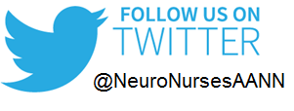

Please use #AANN20 in your communications. If you tag @NeuroNursesAANN, we can respond and retweet your communications to our followers as well.

Tweet Example 1: I can’t wait to present at #AANN20! Join me for my session [INSERT SESSION TITLE] & @NeuroNursesAANN in Orlando, April 18-21.

Tweet Example 2: On April [INSERT DATE] see me present [INSERT SESSION TITLE] at #AANN20 in Orlando with @NeuroNursesAANN. Learn more: AANN.org/AnnualMeeting.

Facebook 

Please tag the American Association of Neuroscience Nurses (by typing @neuronurses, a dropdown box with the proper tag will show up, select ‘American Association of Neuroscience Nurses’) in your post.

Use the conference hashtag: #AANN20, whenever possible.

Sample Facebook Posts

If your organization or business has a Facebook page, you may wish to post in the third person:

Example Facebook Post 1: We’re pleased to see our very own [YOUR NAME] presenting [INSERT TITLE OF SESSION] at #AANN20, the @Neuronurses Annual Meeting in Orlando on April [INSERT DATE].

On your personal Facebook page, you may wish to elaborate upon your presentation further:

Example Facebook Post 2: I’m honored and excited to present at #AANN20 this year! Join me for my [INSERT SESSION TITLE] on April [INSERT DATE]. I hope to see you there. Learn more: AANN.org/AnnualMeeting.

